**A**

**PROJECT REPORT**

**ON**

**“Novelty driven AutoRecs Personalized Vehicle Recommendation System”**

Submitted to the





**in fulfillment of the requirements for the award of the degree**

**BACHELORS OF TECHNOLOGY**

# COMPUTER SCIENCE AND ENGINEERING

**2023-2024**

BY

|  |  |
| --- | --- |
| **Himaxi Vachhani** | **2064191242026** |
| **Manasi Chaugule** | **2064191242033** |
| **Mrunmai Kukudkar** | **2064191242036** |
| **Pratham Joshi** | **2064191242046** |

**UNDER THE GUIDANCE OF**

 ***Prof. Tejaswini Zope***

#### DEPARTMENT OF COMPUTER SCIENCE AND ENGINEERING

**PCET-NMVPM’s**

NUTAN COLLEGE OF ENGINEERING AND RESEARCH TALEGAON, PUNE 410507

|  |  |  |
| --- | --- | --- |
|  | **PCET-NMVPM’s**  **NUTAN COLLEGE OF ENGINEERING & RESEARCH TALEGAON, PUNE**  DEPARTMENT OF COMPUTER SCIENCE AND ENGINEERING |  |
|  |  |  |
|  |  |  |

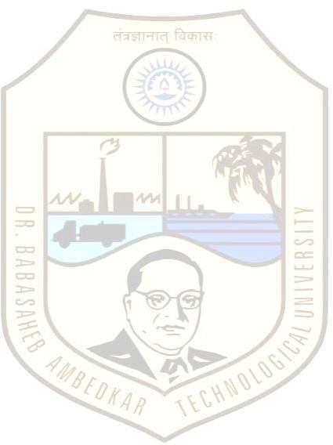 

This is to certify that the Project Report entitled “NOVELTY DRIVEN AUTORECS PERSONALIZED VEHICLE RECOMMENDATION SYSTEM”, which is being submitted by **Himaxi Vachhani**, **Manasi Chaugule**, **Mrunmai Kukudkar**, **Pratham Joshi** as partial fulfillment for the Degree Bachelor of Technology (Computer Science and Engineering) of **DBATU, Lonere**.

This is bonafide work carried under my supervision and guidance.

Place: Pune

Date: /06/2024

|  |  |
| --- | --- |
| *Prof. Tejaswini Zope*  **Project Guide** | *Prof. Dhawase D. V.*  **Project I/C** |
| *Prof. Sanjeevkumar Angadi*  **Head of Department** | *Dr. Aparna Pande*  **Principal** |

**External Examiner [Name & Sign]**